NAME: Umme Iman

USN: 22BTRSNO55

SEM/SEC: 2nd CSE-SE

Github Link:

Blogger:

**ABSTRACT**

Age Calculator an application where a user enters his date of birth as an input, and the application gives his age as an output.  To create an age calculator, you need two dates:

1. today’s date
2. date of birth

You can either ask the user for both dates or just ask for the date of birth and use today’s date from the computer itself. Asking for the birthday only seems like a more user-friendly option.

**1.PROBLEM STATEMENT**

You have been tasked to develop an Age calculator program that takes person’s date of birth as input and calculates their current age in years , months and days.The program should provide user-friendly interface for presenting the date of birth and display the calculated age in clear format

**2.METHODOLOGY**

1. I have to first defined a Python function where I am asking for three user inputs:
   * y: year of birth
   * m: month of birth
   * d: date of birth
2. Then I am importing the datetime module in Python inside the function ,months and days
3. Then in the next line, I am taking today’s date by using the datetime.now() method of the datetime module
4. Then I have introduced a new variable in the next line as dob, where I am using the date of birth as the input given by the user
5. Then I am subtracting the dob with today’s date and then dividing it by 365.25 which is returning the age of the user.

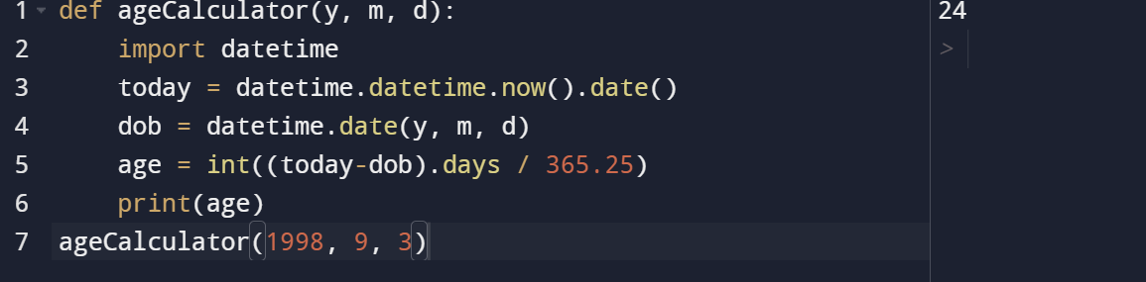

**CONCLUSION**

 It is an application where a user enters his date of birth as an input, and the application gives his age as an output.